# Import ODI Work Repository

1. Export Repository from source environment (usually Prod), and copy to target server
2. Create a new empty work repository
3. Import the Repository

(The best approach is to create a new schema in the database for the work repository, otherwise you will overwrite the only version you current have)

## To prepare the Work Repository for import:

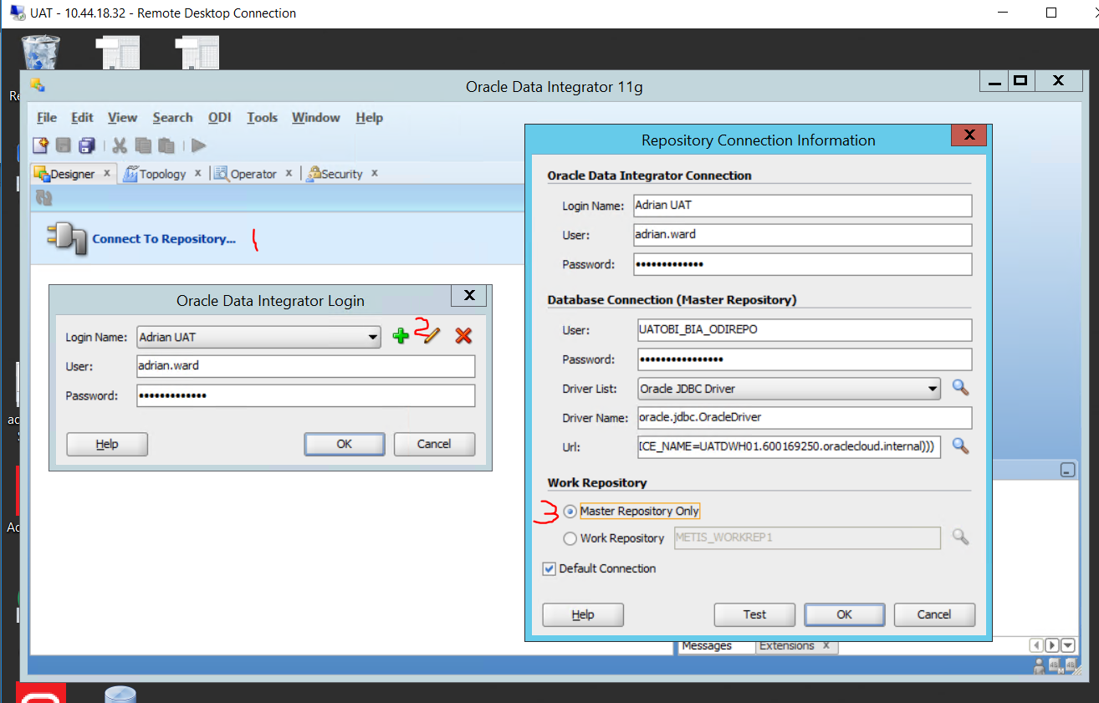

* Load ODI studio
* Connect to repository
* Edit Connection
* Change connection to Master Repository Only

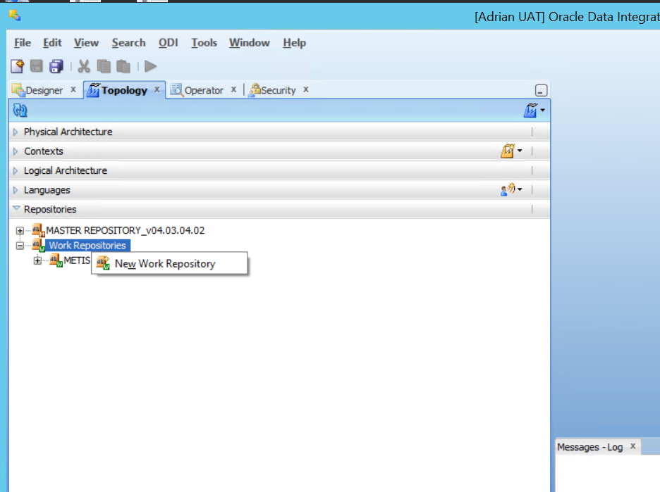

Navigate to Topology .. Repositories

* Right Click Work Repositories
* Select *New Work Repository*

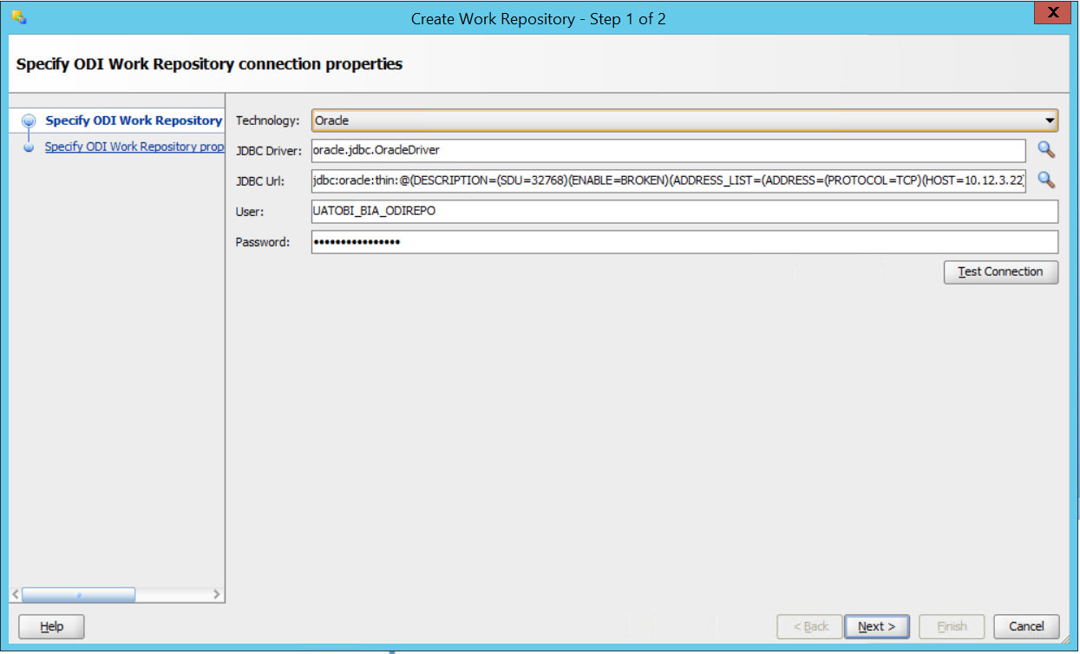

Check the JDBC Url setting includes the tuning parts (SDU, Broken setting)

(At this point, if you have used the existing schema, then you will get a message to overwrite. I would normally just delete the repository first, by..

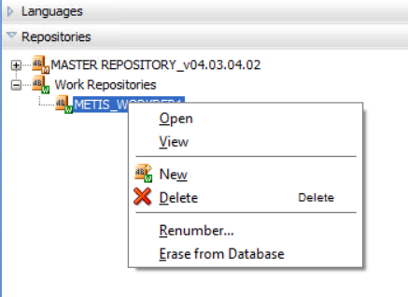

* Choose Erase from database
* Provide a name and an Id

## To run the Import

Reconnect to the Repository

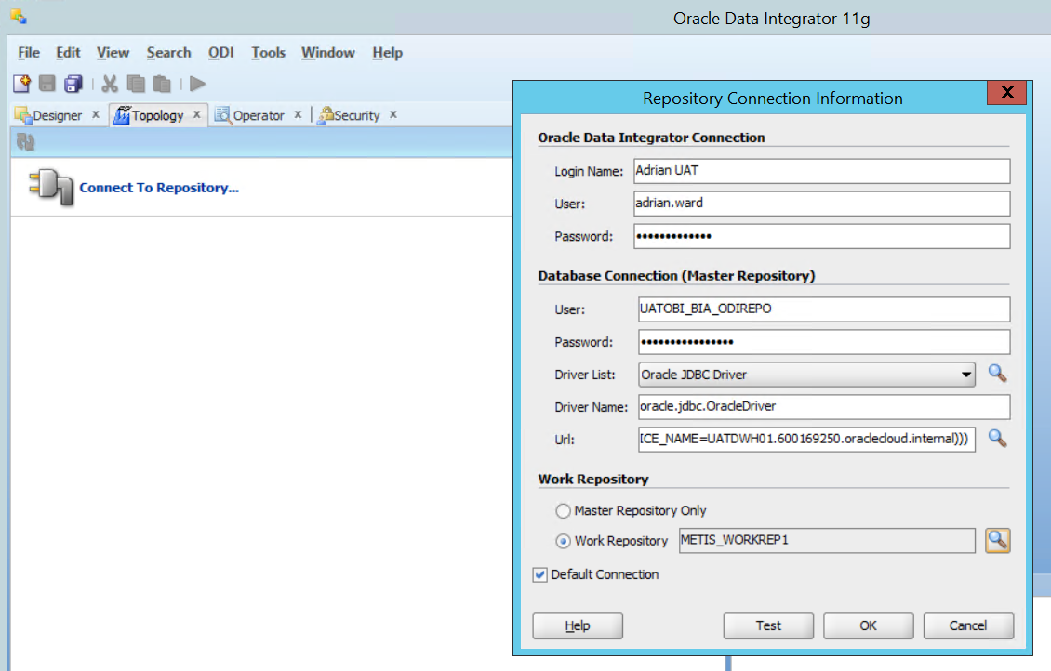

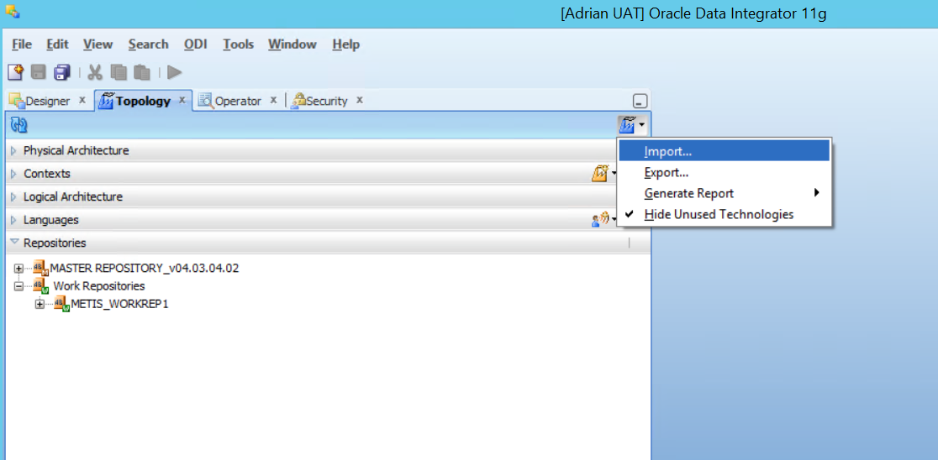

* Select the Import menu item

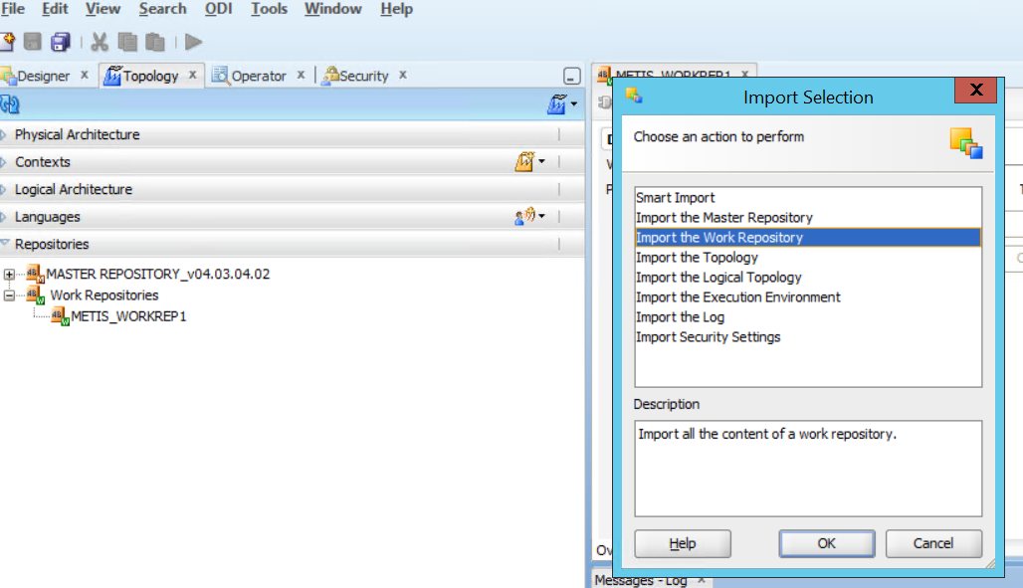

* Select Import the Work Repository

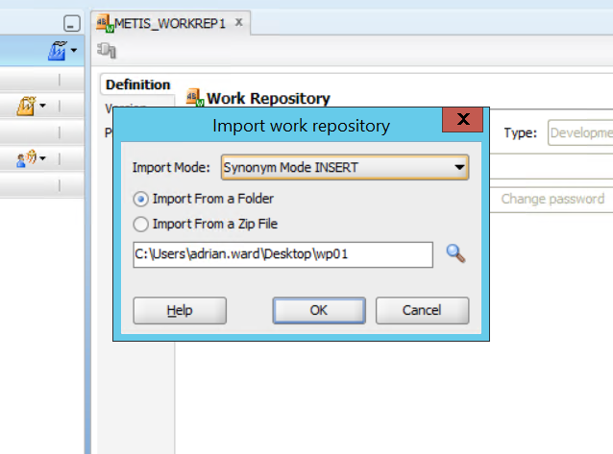

* Select the path to your exported code